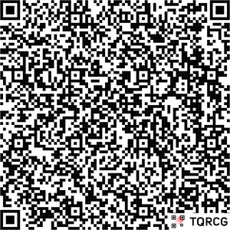
WE ARE
HIRING
JOIN OUR TEAM
JOB FAIR

FEBRUARY 19 NOON-3PM
2
ND FLOOR TRAINING ROOM
APPLY NOW
HARRAH’S PHILADELPHIA

